Experiment 5

:Harmonic Oscillator Part I. Spring Oscillator.

Name: Jonathan Goh

UID: 404901382

Date Performed: 5/16/18

Lab Section: Wednesday 8 a.m.

TA: She, Zhenyu

Partner: Daniel Schwartz

Calculating Frequencies in Damped and Undamped Oscillating Systems

J.R. Goh1

An oscillating mass-spring system undergoes harmonic motion, which can be described by specific equations, that have undergone thorough testing by many physicists. Using these sets of equations, we can apply our theoretical knowledge about harmonics to accurately predict the frequency of damped and undamped oscillators in our own experiment. We first determined the spring constant of our system, measuring displacement of the spring with respect to different applied forces. The undamped oscillator required a mass to be freely suspended from a spring that was attached to a force sensor, and an initial force was exerted to start the motion. The damped oscillator had the exact same setup as the undamped oscillator did, but with the addition of an aluminum damping tube that was put along the path of the the oscillating mass. Using the recorded data, plots of Voltage vs. Time were created for both cases. From the graphs it was shown that the undamped oscillation had a resonant frequency of about $0.670±0.002 Hz$, while the damped oscillation had a resonant frequency of $0.680±0.01 Hz$. It was later observed that the predicted resonant frequency matched the calculated resonant frequency, derived from the given equations.

Word Count: 199

1 *Department of Engineering, Henry Samueli School of Engineering and Applied Sciences, University of California Los Angeles.*

1. Introduction

Harmonic motion is a special type of periodic motion that describes the movement of an object that oscillates back and forth about an equilibrium position, and moves along the same path. Harmonic Motion is often times described through use of pendulums and springs, but can actually be seen all around us, for example the vibration of strings on a guitar. Scientists including Robert Hooke, Jean Fourrier, and Galileo all studied harmonic motion, being the first to describe the motion of oscillators through mathematical equations. Simple harmonic motion describes an oscillation in which the force acting upon the body is proportional to the displacement of that body, this represents an ideal undamped oscillation. Damped oscillations on the other hand must take into account external forces that may be acting on the oscillator.

The purpose of this experiment was to verify that both defined methods for calculating the resonant frequency resulted in the same answer, and to investigate the behavior of damped and undamped oscillators. To create the apparatus for the undamped oscillator, a mass must be freely suspended from a spring that is attached to a force sensor, and an initial force must be exerted to set the oscillator in motion. To set up the damped oscillator, aluminum damping tube that was put along the path of the the oscillating mass from the previous apparatus. The magnets embedded into the mass create a damping force when put along the aluminum tube path. Using the two predefined methods, values for resonant frequencies were predicted and calculated. Lastly, the values each value of frequency was compared to verify that both calculations of resonant frequency were completed correctly.

Word Count: 274

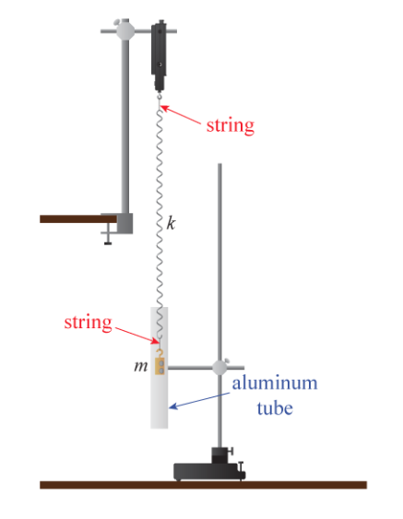

**Figure 5.6: Diagram of Oscillator Apparatus**

1. Methods

Before collecting the data to calculate the values of resonant frequency, the spring constant ($k$) must be calculated. In order to properly calculate $k$, a series of masses (i.e. 0.996 kg, 0.813 kg, 0.665 kg, 0.512 kg, 0.363 kg, and 0.211 kg) must weighed and attached to the end of a spring; the distance from the ground must be recorded so that a plot can be made of the Force ($mass⋅9.8$) versus the Distance from the floor to the edge of the spring. Once the plot is created, run a regression on the data to calculate the equation of the line of best fit and the uncertainty of the slope. The slope (coefficient of x) and the uncertainty represent the value and uncertainty of the spring constant ($k$).

Next, the apparatus depicted in **Figure 4.8** must be setup without the aluminum tube for the undamped oscillation. Essentially, a force sensor must be hung from a metal clamp, pointed downward, so that the hook is facing towards the ground. Attach the force sensor probes to their respective ports and set the DAQ to record the voltages over time, which is representative of the applied tension force over time. A string should be added between the force sensor hook and the spring and also between the spring and the mass with embedded magnets; this is a way to mitigate the systematic uncertainty due to the stretching and compression of the springs. The string is used to decouple the rotation (prevent systematic uncertainty). When collecting data, a small amplitude of oscillation should be used to prevent distortion of the spring and to prevent the coils from touching one another during oscillation (prevent systematic uncertainty). Data is recorded for 20 seconds and is then transferred to an excel spreadsheet, make sure that the sample rate is between 20k and 50k Hz.

Next, the aluminum tube should be added to the apparatus to observe the damped oscillation. Ensure that the mass with the embedded magnets is the mass that is being used to experiment with. The magnets provide the damping force along the path of the aluminum tube. Once again, a string should be added between the force sensor hook and the spring and also between the spring and the mass with embedded magnets; this is a way to mitigate the systematic uncertainty due to the stretching and compression of the springs. The string is used to decouple the rotation (prevent systematic uncertainty). When collecting data, a small amplitude of oscillation should be used to prevent distortion of the spring and to prevent the coils from touching one another during oscillation (prevent systematic uncertainty). Data is recorded for 20 seconds and is then transferred to an excel spreadsheet, make sure that the sample rate is between 20k and 50k Hz.

The final step is to start the calculations and analyze the raw data.

Word Count: 488

1. Analysis

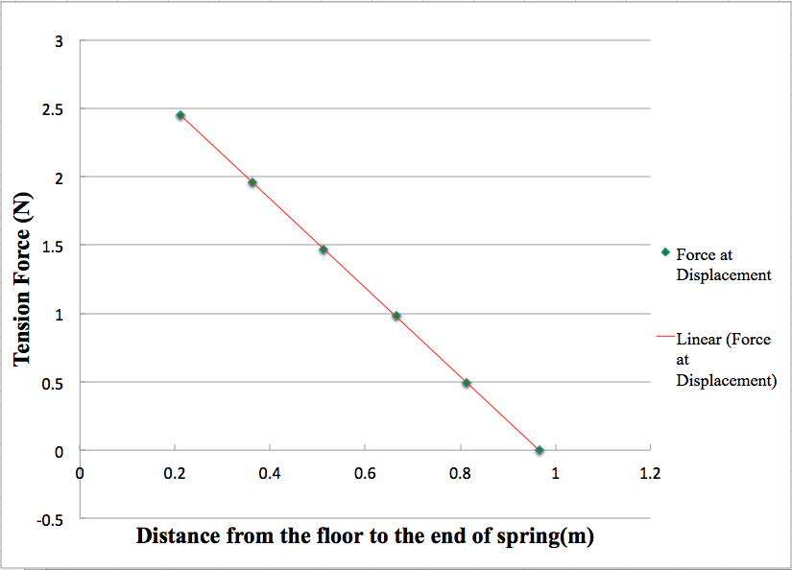

**Figure 5.1: Plot to Determine Spring Constant Using Five Different Masses.** Mass values of 0.996 kg, 0.813 kg, 0.665 kg, 0.512 kg, 0.363 kg, and 0.211 kg hung from the spring to gather the plotted data. The equation of the line of best fit was calculated to be $F=-3.2493x+3.1367$. The equation for the line of best fit is given in the form of $y=ax+b$. $x$ is (m), distance from the floor to the end of the spring, $y$ is (F), tension force, $a$ is the slope of the line which also represents the estimated value of $k$, and $b$ represents the $y intercept$. The value of $k=3.249±0.006 N/m$.

*To predict the Resonant Frequency of an undamped oscillator we use the equation:

$f{}_{o}=\frac{1}{2π}\sqrt{\frac{k}{m}}$

Given that:

The hanging mass ($m$) is $173.00±.05 grams$ or $0.17300±0.0005 kilograms$

The spring constant ($k$) is $3.249±0.006 N/m$

Substituting the given values:

$f{}_{o}=\frac{1}{2π}\sqrt{\frac{3.249}{.17300}}=0.670 Hz$

Calculating uncertainty using the propagation of uncertainties formula ($×/÷)$:

$δf{}_{o}=f{}_{o, best}×\sqrt{(\frac{δk}{k{}_{best}}){{}^{2}+(\frac{δm}{m{}_{best}}){}^{2}}^{}}=0.002$

Therefore the predicted value of $f{}_{o}$:

$f{}_{o, predicted}=0.670±0.002 Hz$

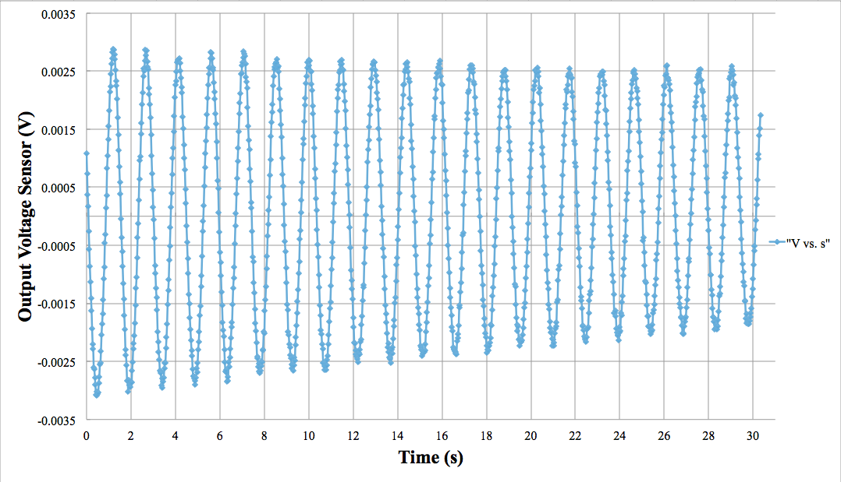

**Figure 5.2: Free oscillation of a mass suspended from a spring.** The points on the graph represent the voltage readings from the force sensor and Capstone software as a mass was oscillated on a spring hung from the force sensor. The x-axis is the time in units of seconds. The y-axis is the force sensor voltage in units of volts. Slight decay can be seen in the amplitude due to the dissipation of the oscillation over time. Using the counts of extrema we can estimate the oscillation frequency (outlined below). The graph was shifted down to the correct baseline by subtracting by 0.0117 V, which was the average over the entire oscillation.

*Calculating undamped frequency using extrema method:

To perform this method we zoom into each maximum to find the time at each position. Using the time at the first and the last extrema we can calculate the period of oscillation for the harmonic motion.

Time at the 20th extrema: 29.025 seconds

Time at the 1st extrema: 1.175 seconds

$T=\frac{(t{}_{n}-t{}_{1})}{n-1}=\frac{1}{f{}_{o}}$

Calculating the period of the oscillation:

$T=\frac{(29.025-1.175)}{19}=1.466 s$

Calculating uncertainty of period using the propagation of uncertainties formula (+/-):

Calculating the frequency of the oscillation:

Calculating uncertainty of frequency using the propagation of uncertainties formula

($×/÷)$:

$\frac{δf{}_{o}}{f{}_{o, best}}=\sqrt{(\frac{δT}{T{}_{best}}){}^{2}}$ or $δf{}_{o}=f{}_{o, best}×(\frac{δT}{T{}_{best}})$

$δf{}_{o}=0.682×(\frac{0.025}{1.466})=0.01$

Therefore the calculated value of $f{}_{o}$:

$f{}_{o, calculated}=0.68±0.01 Hz$

*Comparison of Predicted and Calculated values of $f{}_{o}$:

As previously shown:

$f{}_{undamped, calculated}=0.68±0.01 Hz$

$f{}_{undamped, predicted}=0.670±0.002 Hz$

% error = 1.48148%

As illustrated by the percent difference there was less than a 2 percent difference between the result of the calculated frequency and the result of the predicted value of frequency. Therefore we can conclude that the results agree and that the values are frequency are the same value. To account for the slight variations, it is important to note that there is a possibility that air resistance or other systematic uncertainties that potentially could have caused the uncertainty.

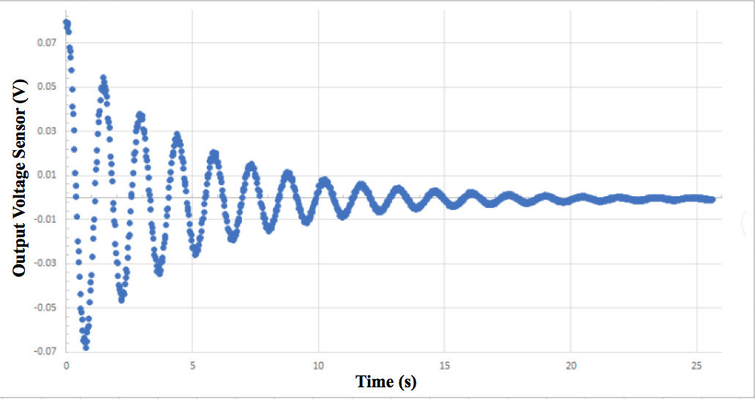

**Figure 5.3: Damped oscillation of a mass suspended from a spring using aluminum tube.** The points on the graph represent the voltage readings from the force sensor and Capstone software as a mass was oscillated, through an aluminum damping tube ,on a spring hung from the force sensor. The x-axis is the time in units of seconds. The y-axis is the force sensor voltage in units of volts. Dissipation in amplitude is evident overtime due to the damping of the aluminum tube and the magnets attached to the mass Using the counts of extrema we can estimate the oscillation frequency (outlined below). The graph was shifted down to the correct baseline (centered) by subtracting by the approximate average over the entire oscillation.

*Calculating damped frequency using extrema method:

To perform this method we zoom into each maximum to find the time at each position. Using the time at the first and the last extrema we can calculate the period of oscillation for the harmonic motion.

Time at the 9th extrema: 12.825 seconds

Time at the 1st extrema: 1.275 seconds

$T=\frac{(t{}_{n}-t{}_{1})}{n-1}=\frac{1}{f{}_{damped}}$

Calculating the period of the oscillation:

$T=\frac{(12.825-1.275)}{8}=1.444 s$

Calculating uncertainty of period using the propagation of uncertainties formula (+/-):

Calculating the frequency of the oscillation:

Calculating uncertainty of frequency using the propagation of uncertainties formula

($×/÷)$:

$\frac{δf{}_{damped}}{f{}_{damped, best}}=\sqrt{(\frac{δT}{T{}_{best}}){}^{2}}$ or $δf{}_{o}=f{}_{damped, best}×(\frac{δT}{T{}_{best}})$

$δf{}_{damped}=0.682×(\frac{0.025}{1.444})=0.01$

Therefore the calculated value of $f{}_{damped}$:

$f{}_{damped, calculated}=0.69±0.01 Hz$

Derivations:

*Deriving $Q$ (The Quality Factor):

$f{}_{damped}=f{{}_{o}\sqrt{1-\frac{1}{4Q^{2}}}}_{}$ and $Q=\frac{\sqrt{km}}{b}$, $Q=$ Quality Factor

$f{}_{damped}=\frac{ω{}_{damped}}{2π}=\frac{1}{2π}\sqrt{\frac{k}{m}-\frac{b^{2}}{4m^{2}}}=f{}_{o}\sqrt{1-\frac{b^{2}}{4km}}$

Set the equation equal to one another:

$f{{}_{o}\sqrt{1-c}}_{}=$ $f_{o}\sqrt{1-\frac{b^{2}}{4km}}$

Solve for the value of $Q$:

$\frac{1}{4Q^{2}}=\frac{b^{2}}{4km} → Q^{2}=\frac{km}{b^{2}} → Q^{}=\frac{\sqrt{km}}{b^{}}$

*Deriving $τ$ (Damping Time- time required to reduce amplitude by factor of 1/e):

Use the differential equation that represents damped motion:

$mẍ=kx-bẋ$

Using $x(t)=Ae^{ιωt}$:

$-ω^{2}mAe^{ιωt} = -kAe^{ιωt}-iωbAe^{ιωt}$

$mω^{2} = k+iωb$

Isolate the $ω$:

$ω=\frac{ib}{2m}±\sqrt{\frac{k}{m}-\frac{b^{2}}{4m^{2}}}$

Substitute $ω$ into $x(t)=Ae^{ιωt}$:

$x(t)=Ae^{ι(\frac{ib}{2m}±\sqrt{\frac{k}{m}-\frac{b^{2}}{4m^{2}}})t}$

Simplify this result to get:

$x(t)=Ae^{ι\sqrt{\frac{k}{m}-\frac{b^{2}}{4m^{2}}}t }×e^{-bt/2m}$

Which is how we derive the final value of $τ$:

$τ=\frac{2m}{b}$

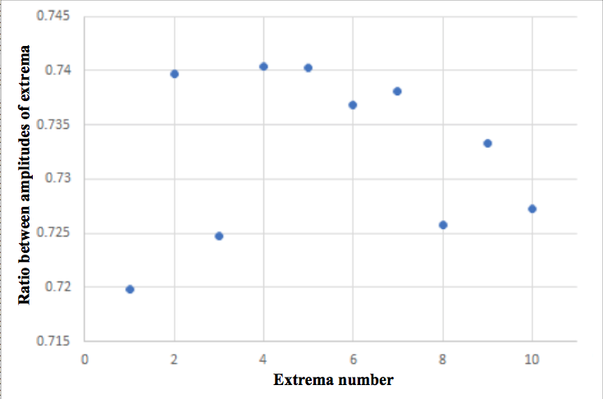

**Figure 5.4: Ratio of successive extremum in a damped oscillation.** Take extrema (n+1) and divide it by extrema (n) to calculate the ratio of successive amplitudes. The ratio between amplitudes was observed to vary from 0.655 - 0.781. There is a slight upward trend in the ratios as the wave is damped over time, this shows that each successive amplitude is decreasing at a slightly lower rate than that of the one before it. Data is centered around a mean value of 0.721.

|  |  |  |
| --- | --- | --- |
| **Extrema Number** | **Extrema Voltage (V)** | **Ratio to subsequent extrema** |
| 1 | 0.0539 | 0.719852 |
| 2 | 0.0388 | 0.739691 |
| 3 | 0.0287 | 0.724739 |
| 4 | 0.0208 | 0.740385 |
| 5 | 0.0154 | 0.74026 |
| 6 | 0.0114 | 0.736842 |
| 7 | 0.0084 | 0.738095 |
| 8 | 0.0062 | 0.725806 |
| 9 | 0.0045 | 0.733333 |
| 10 | 0.0033 | 0.727273 |

**Figure 5.5: Damping Ratio Table.** The mean of the ratio data was calculated to be $0.0733±0.008$, uncertainty was calculated by using the statistical uncertainty through a basic standard deviation.

*Calculation of $τ$:

Solve for $τ$ using the calculated ratios:

$τ=\frac{T}{ln(\frac{V(t+T)}{V(t)})}$ using the fact that $T=1/f{}_{damped}$

$f{}_{damped}=\frac{1}{T}=\frac{1}{1.444±0.01}=0.69±0.01 Hz$

The mean value of $τ$ calculated using the mean value of the ratios:

$τ=-\frac{1}{f{}_{damped} × ln(R)}$

$τ=-\frac{1}{ (0.69 ± 0.01)×ln(0.733 ± 0.008)}=4.67±0.05 s$

The uncertainty of τ:

The uncertainty of *ln(R)* is equivalent to the fractional uncertainty of *R:*

$δln(R)=\left|ln(R){}_{best}\right|\frac{δR}{R{}_{best}}$

$δ(f{}_{damped }×ln(R)) =\left|(f{}_{damped }×ln(R)){}_{best}\right|\sqrt{\left(\frac{δf{}_{damped }}{f{}_{damped , best}}\right){}^{2}+\left(\frac{δln(R)}{ln(R){}_{best}}\right){}^{2}}$

$δτ=\left|τ{}_{best}\right|×\frac{δ(f{}_{damped }×ln(R))}{\left|(f{}_{damped }×ln(R)){}_{best}\right|}=4.6659×0.011=0.051$

*Calculated value of τ:

$τ=4.666±0.051$

*Using $τ=\frac{2m}{b}$ we can calculate for the unknown value of $b$:

$b=\frac{2m}{τ}=\frac{2(0.17300±0.0005)}{4.666±0.051}=0.074$

Calculating Uncertainty (Using above uncertainties):

$δb=b{}_{best}×\sqrt{(\frac{δm}{m{}_{best}}){{}^{2}+(\frac{δτ}{τ{}_{best}}){}^{2}}^{}}=0.001$

*Calculated value of :

*Using we can calculate for the unknown value of $Q$:

$Q^{}=\frac{\sqrt{km}}{b^{}}=\frac{\sqrt{(3.249±0.006)(0.17300±0.0005)}}{{0.074±0.001}^{}}=10.131$

Calculating Uncertainty (Using above uncertainties):

$δQ=Q{}_{best}×\sqrt{(\frac{δm}{m{}_{best}}){{}^{2}+(\frac{δk}{k{}_{best}}){}^{2}+(\frac{δb}{b{}_{best}}){}^{2}}^{}}=0.1$

*Calculated value of :

*Using we can calculate for the unknown value of $f{}_{damped}$:

$f{}_{damped}=f{{}_{o}\sqrt{1-\frac{1}{4Q^{2}}}}_{}=$ $(0.69±0.01){\sqrt{1-\frac{1}{4{(10.1±0.1)}^{2}}}}_{}=0.68$

Calculating Uncertainty (Using above uncertainties):

$δf{}_{damped}=f_{damped, best}×\sqrt{(\frac{δQ}{Q{}_{best}}){{}^{2}+(\frac{δf{}_{o}}{f{}_{o, best}}){}^{2}}^{}}=0.01$

*Calculated value of $f{}_{damped}$:

$f{}_{damped, predicted}=0.68±0.01 Hz$

*Comparison of Predicted and Calculated values of $f{}_{o}$:

As previously shown:

$f{}_{damped, predicted}=0.68±0.01 Hz$

$f{}_{damped, calculated}=0.69±0.01 Hz$

% error = 1.4706%

As illustrated by the percent difference there was less than a 2 percent difference between the result of the calculated frequency and the result of the predicted value of frequency. Therefore we can conclude that the results agree and that the values are frequency are the same value. To account for the slight variations, it is important to note that there is a possibility that air resistance or other systematic uncertainties that potentially could have caused the uncertainty.

1. Conclusion

The purpose for the experiment was to to investigate the behavior of damped and undamped oscillators. The values of resonant frequency that were predicted were extremely close to the values of resonant frequency that were calculated. As seen through the calculations: The value of $f{}_{damped, predicted}=0.68±0.01 Hz$ versus $f{}_{damped, calculated}=0.69±0.01 Hz$ only showed a 1.4706 percent error. Similarly, the value of $f{}_{undamped, calculated}=0.68±0.01 Hz$

versus $f{}_{undamped, predicted}=0.670±0.002 Hz$, also showed a small percent error of about 1.48148 percent. The small amount of error can be attributed to some external variables that could have potentially caused inaccuracies during data collection.

One possible cause for error was the fact that air resistance on the oscillator was not taken into account. Because air resistance is proportional to velocity squared, it would have more effect on the oscillation when the amplitude was large, causing a slight increase in the ratios of the extrema over time. In order to mitigate this external variable, the apparatus could be built and run inside of a vacuum, however, it is not the most practical lab setup. Another possible source of error could be that as the spring gets used and stretched through the experimentation process, the spring constant could get distorted. If this happened, the spring constant would increase, causing our measured frequencies to be much higher than the predicted frequencies. This variable can potentially be accounted for if the spring constant is measured after each oscillation.

1. Bibliography

Campbell, W. C. et al. Physics 4AL: Mechanics Lab Manual (ver. August 31, 2017). (Univ. California Los Angeles, Los Angeles, California).

Young, Hugh D, Roger A. Freedman, A L. Ford, and Francis W. Sears. Sears and Zemansky's University Physics: With Modern Physics. San Francisco: Pearson Addison Wesley, 2004. Print.